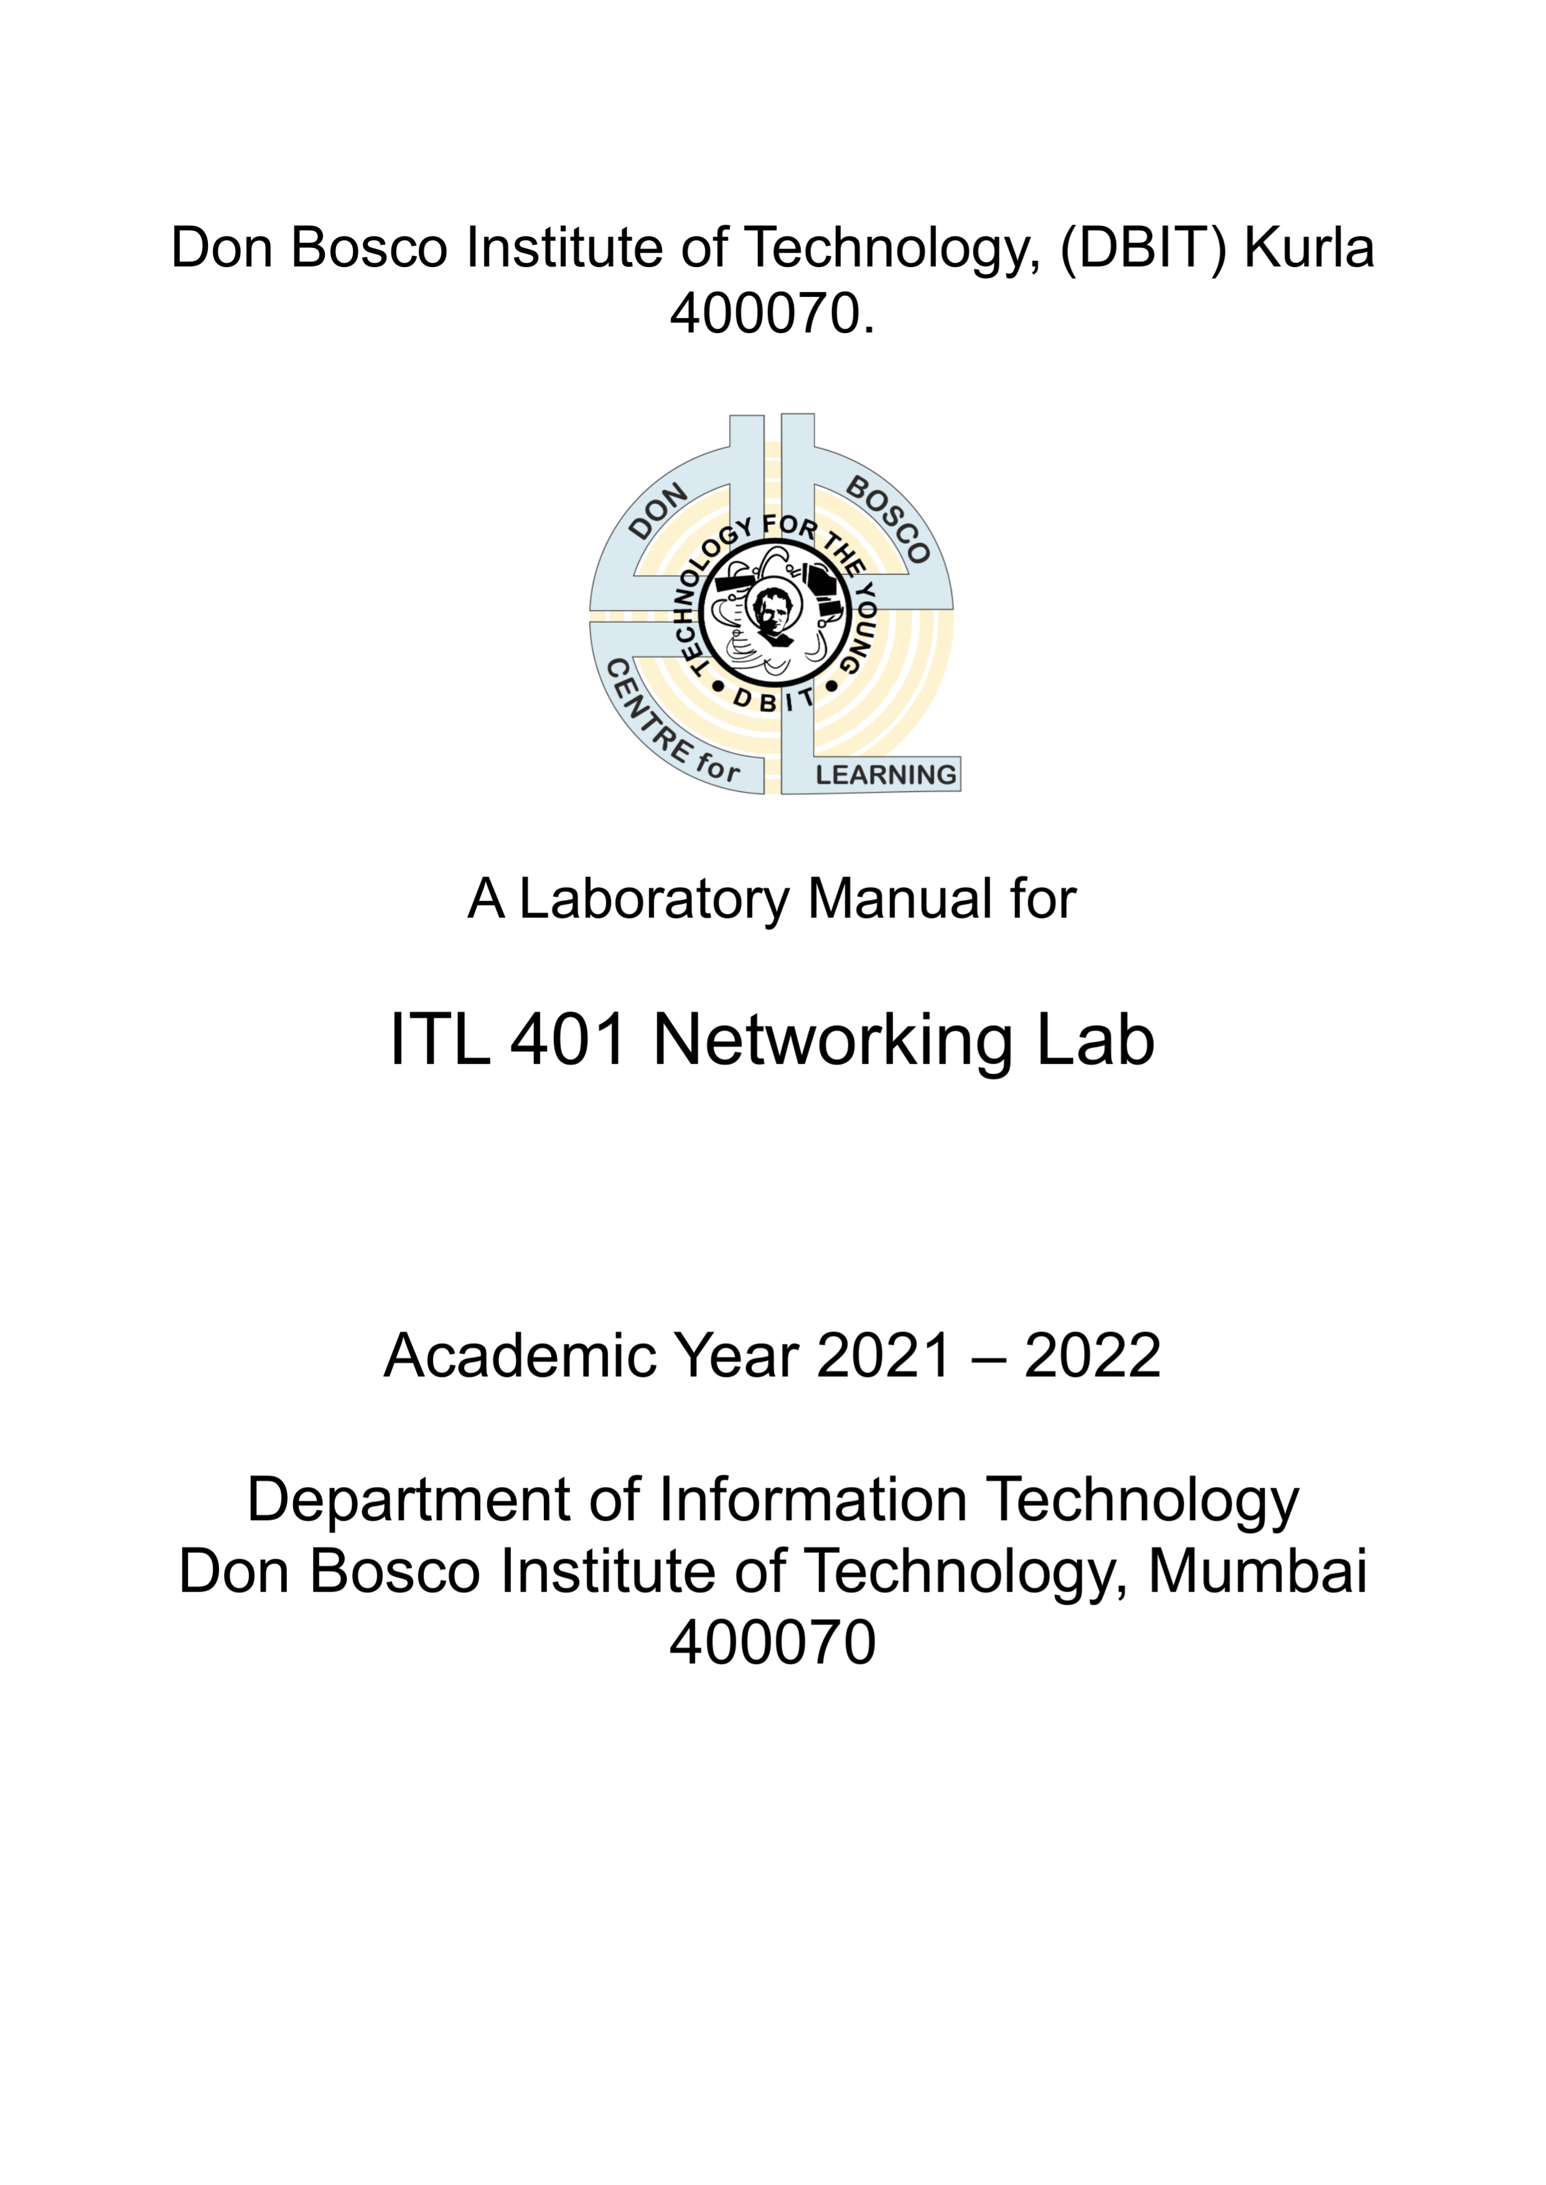

Name : ANIKET VINAYAK PARATE
Name : Aniket Vinayak Parate
Class : SE IT
Roll No : 38
Seat No : 3446
Batch : B
Subject: Networking Lab

Exp No | Title | Date of performance | Page No
1 | Basic NW Commands | 14-02-2022 | 3
2 | Wireshark | 17-02-2022 | 7
3 | Basic NS2 | 23-02-2022 | 12
4 | NS2 Topology | 23-02-2022 | 14
5 | NS2 TCP Traffic | 09-05-2022 | 17
6 | DV | 09-05-2022 | 19
7 | Socket Programming TCP | 14-03-2022 | 23
8 | Socket Programming UDP | 14-03-2022 | 27
9 | Cisco Packet Tracer | 09-05-2022 | 30
10 | Cisco HTTP DNS DHCP | 09-05-2022 | 35

Experiment No. 1

AIM : To understand basic networking command

Objective:
- To understand basic commands used in the networking domain.
- Student should be able to find out IP/MAC address, IP packet status, link status, network statistic, Port scanning etc

Theory:
1) Netstat -at :
Netstat is a command line utility that can be used to list out all the network (socket) connections on
a system. It lists out all the tcp, udp socket connections and the unix socket connections.
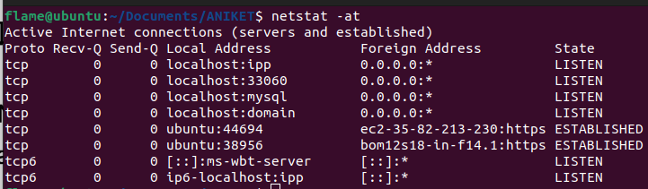
2) Netstat -i :
To get the list of network interfaces
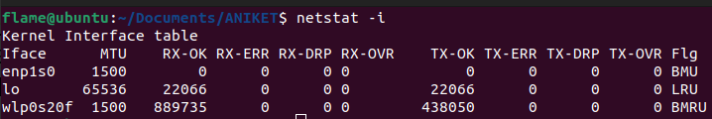

3) Netstat -ie :
To display extended information on the interfaces
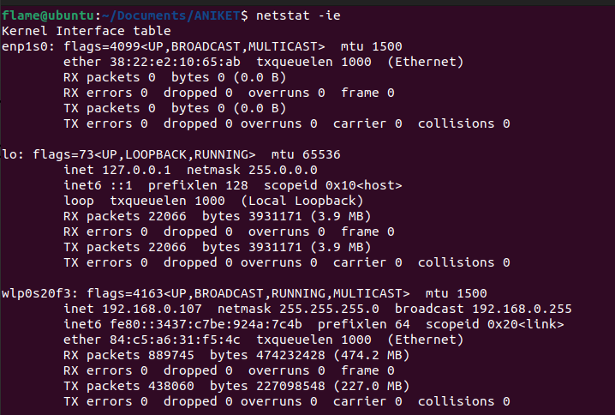

4) Netstat -tlpe :
To get user information
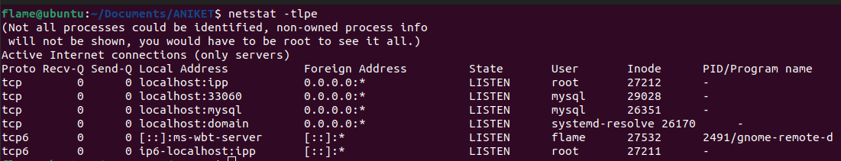
5) Netstat -ntlp :
To get process name
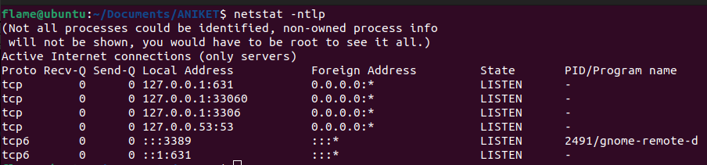
ifconfig :
Interface configuration
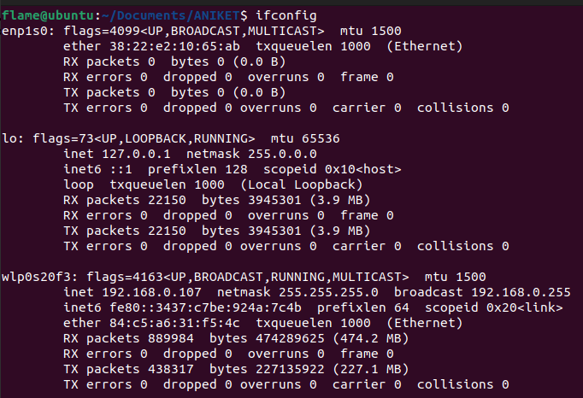
Tcpdump :
This is a sniffer, a program that captures packets off a network interface and interprets them for you.
It understands all basic INTERNET protocols, and can be used to save entire packets for later
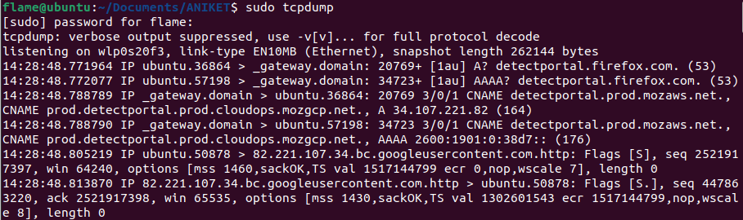
inspection.

Traceroute :
Traceroute will show the route of a packet. It attempts to list the series of hosts through which your
packets travel on their way to a given destination.
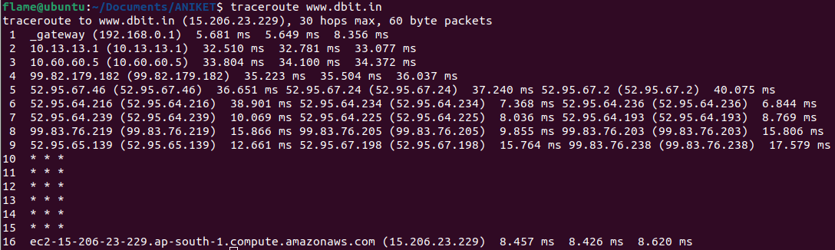

Nmap :
"Network exploration tool and security scanner''. nmap is a very advanced network tool used to
query machines (local or remote) as to whether they are up and what ports are open on these
machines.
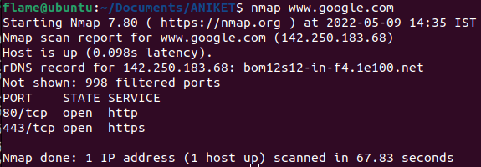

Hostname :
Tells the user the host name of the computer they are logged into.
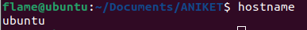

Ping :
The ping command (named after the sound of an active sonar system) sends echo requests to the
host you specify on the command line, and lists the responses received their round trip time.
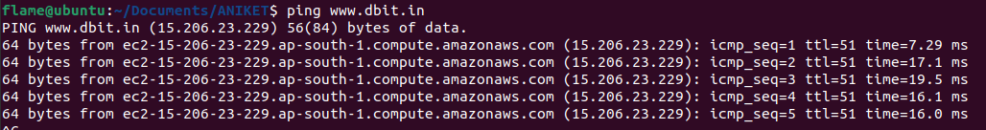
Whois :
This command allows you to check the lnternic database for proper hostnames.
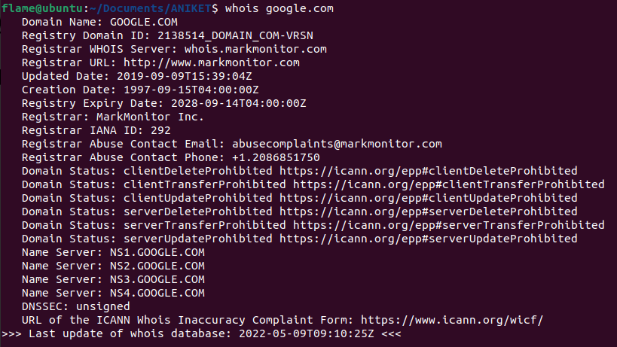

Conclusion : All basic network commands are performed.

Experiment No. 2

Title : Getting familiar with Wireshark

Problem Definition :
Trace the packet related to one connection using wireshark.

Prerequisite :
OSI and/or TCP/IP protocol stack.

Learning Objectives :
1. Students will be able to sniff and find protocol stack details from packets
2. Students will be able to use Wireshark filters effectively.

Results :
1 | Is the frame an outgoing or an incoming frame?  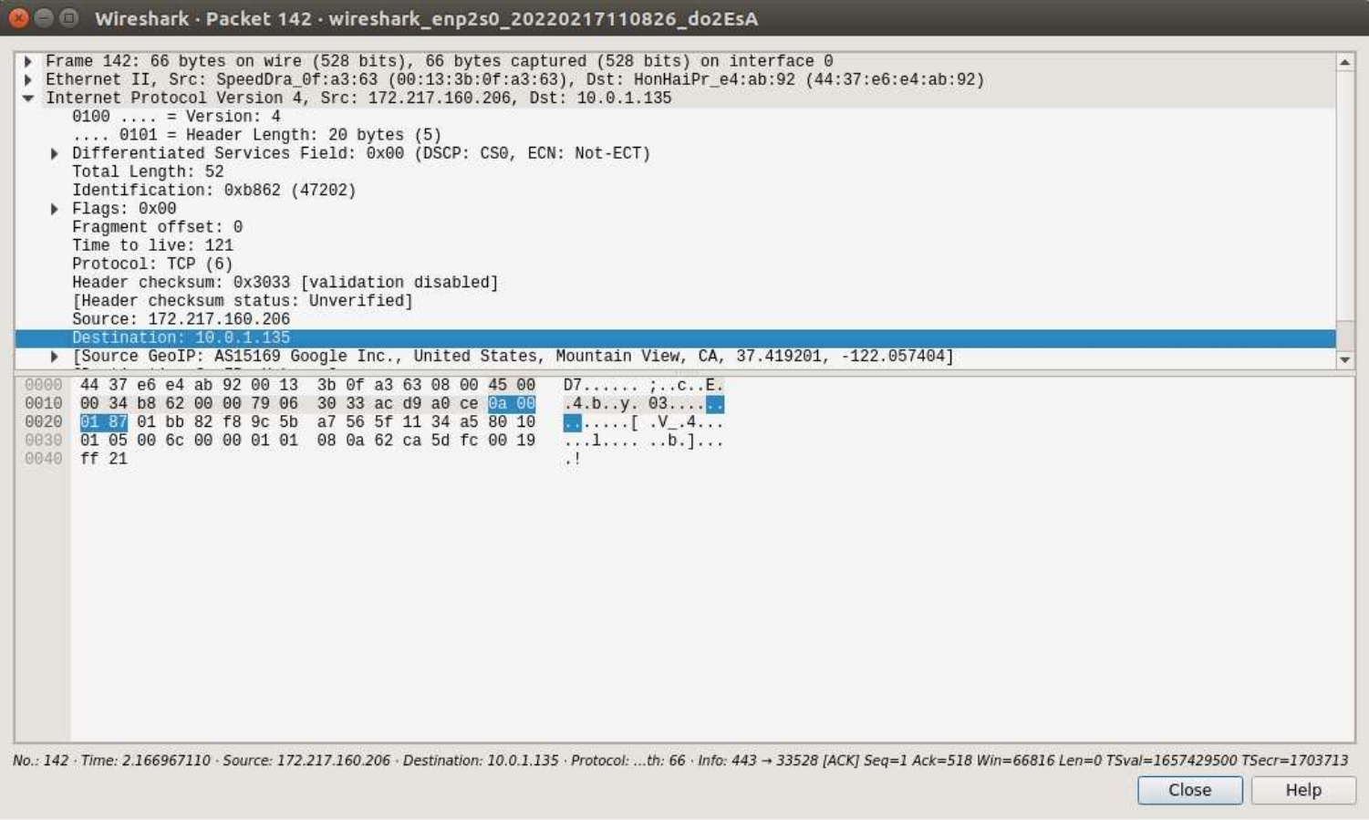  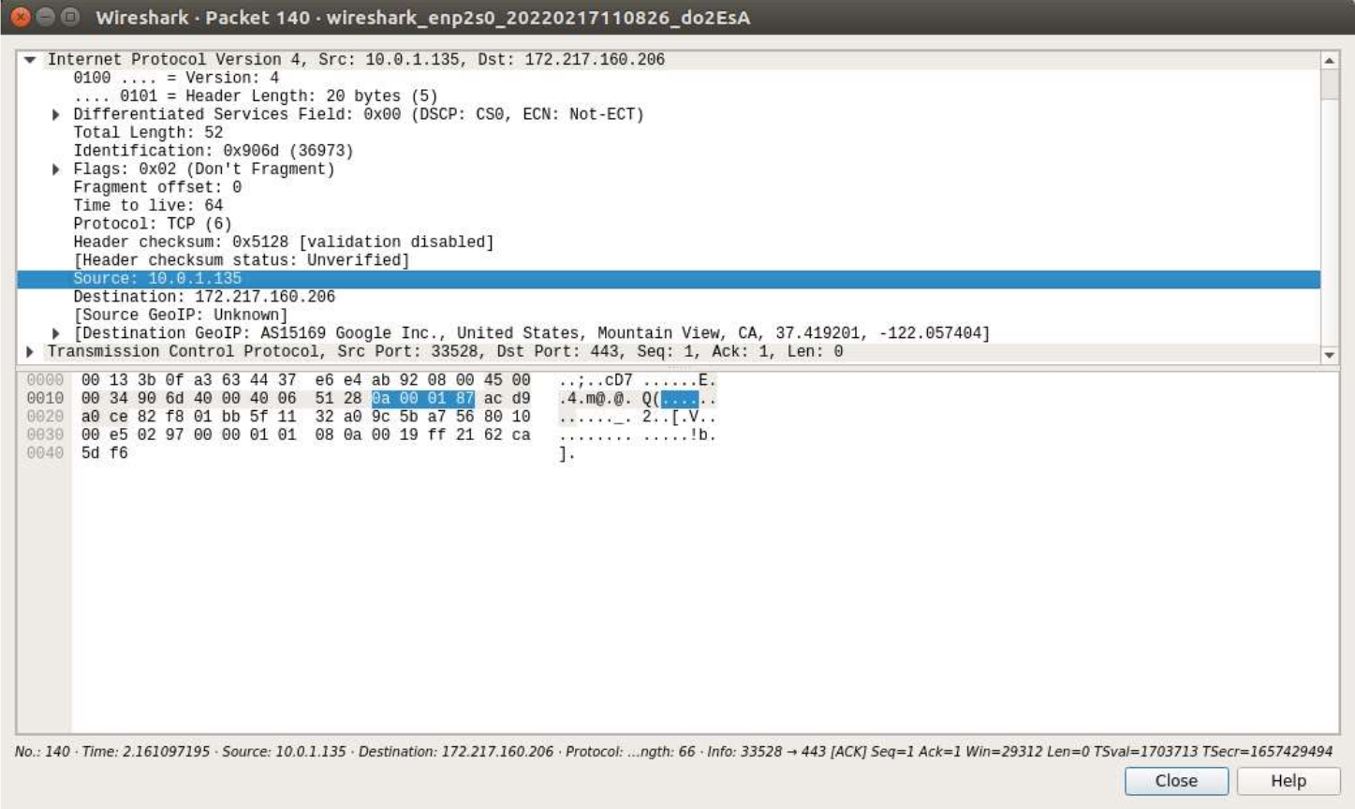
2 | Source IP address of the network-layer header in the frame:
3 | Destination IP address of the network-layer header in the frame:
4 | Total number of bytes in the whole frame:  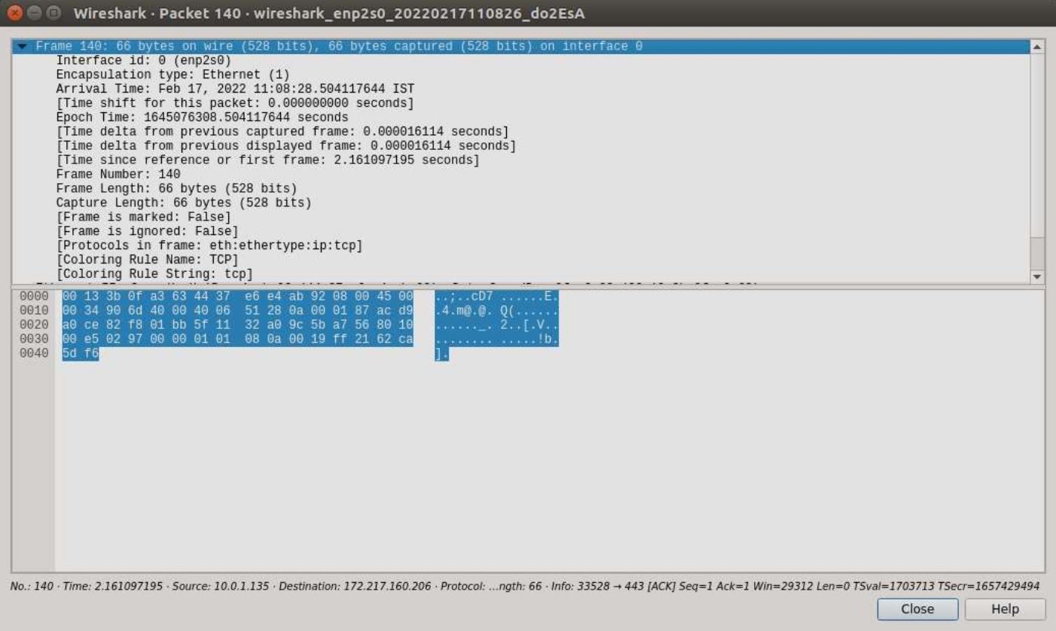
5 | Number of bytes in the Ethernet (data-link layer) header:  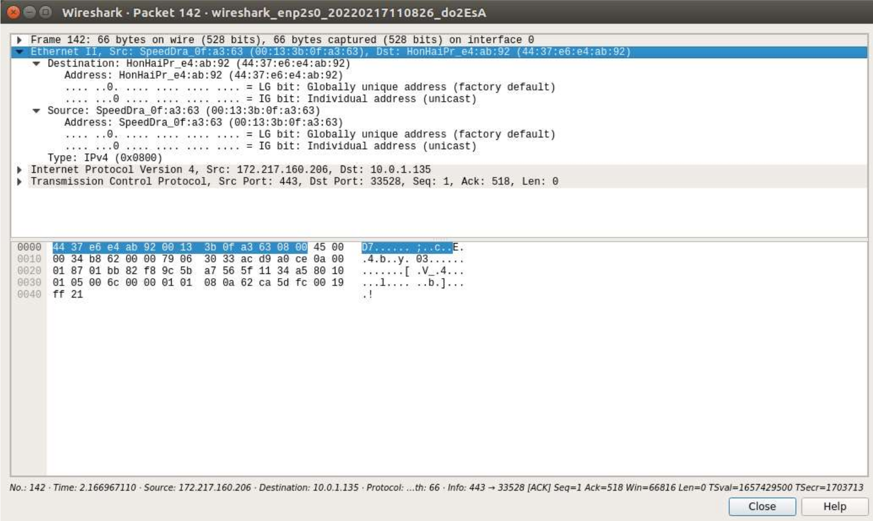
6 | Number of bytes in the IP header:  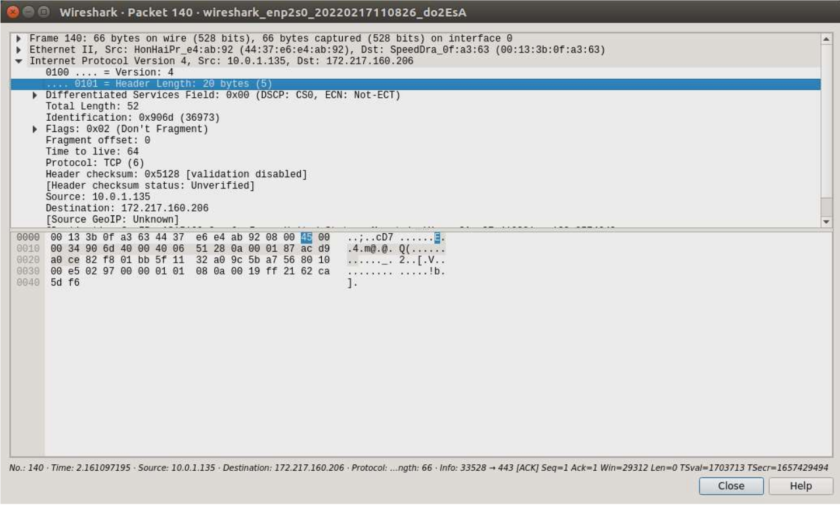
7 | Number of bytes in the TCP header:  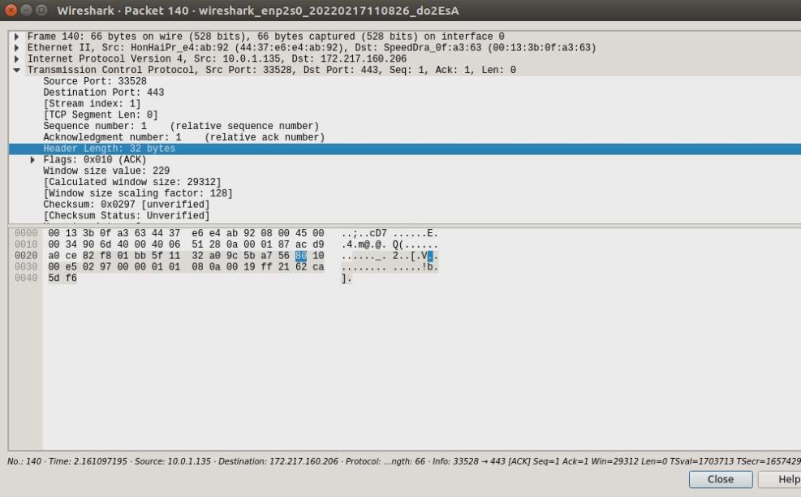
8 | Total bytes in the message (at the application layer):  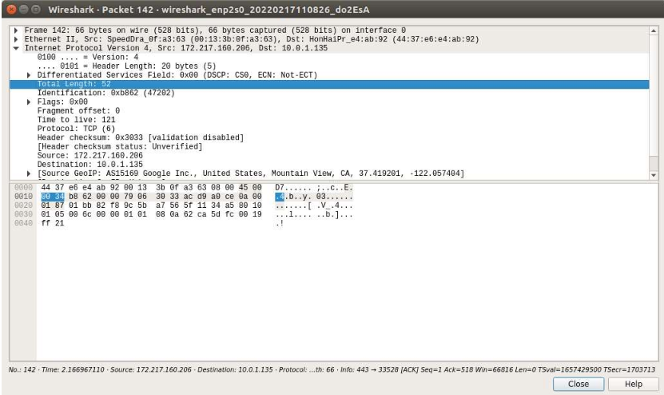  “IP→Total length” = ( ip header length + Tcp header length + application)  52 = 20 + 20 + application  Application = 12 byte

Conclusion :
All the wireshark questions are solved.

Experiment No. 3

Aim : Installation and configuration of NS2

Lab Outcome : ITL401.2 (Demonstrate the installation and configuration of network simulator.)

Installation of NS2 on Ubuntu 16.04 :
1. Open terminal
2. Sudo apt-get update
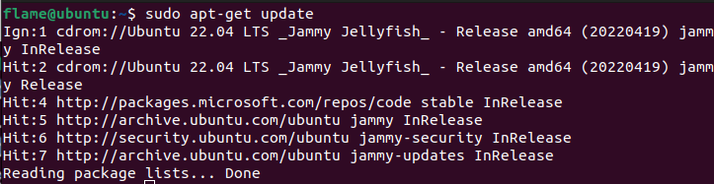
3. sudo apt-get install ns2* nam*
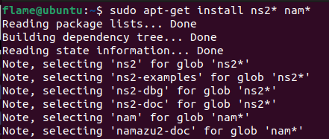

4. sudo apt-get purge nam
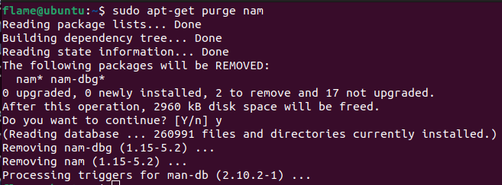

5. wget --user-agent="Mozilla/5.0 (Windows NT 5.2; rv:2.0.1)Gecko/20100101 Firefox/4.0.1"
http://technobytz.com/wp-content/uploads/2015/11/nam_1.14_amd64.zip
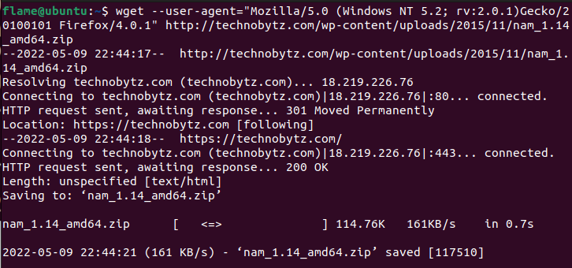

6. unzip nam_1.14_amd64.zip
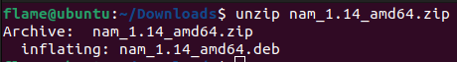

7. sudo dpkg -i nam_1.14_amd64.deb
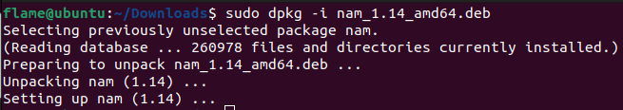

8. Installation is complete.

Conclusion : Hence we have successfully installed NS2.

Experiment No. 4

Aim : Implementation of Specific Network topology with respect to Number of nodes and physical layer configuration

Lab Outcome : Demonstrate and measure different network scenarios and their performance behaviour.

Theory : In this section, we are going to develop a Tcl script for ns which simulates a simple topology. We are going to learn how to set up nodes and links, how to send data from one node to another, how to monitor a queue and how to start nam from our simulation script to visualize our simulation.

1. How to start
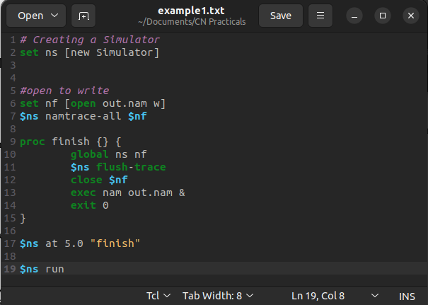

2. Two nodes, one link
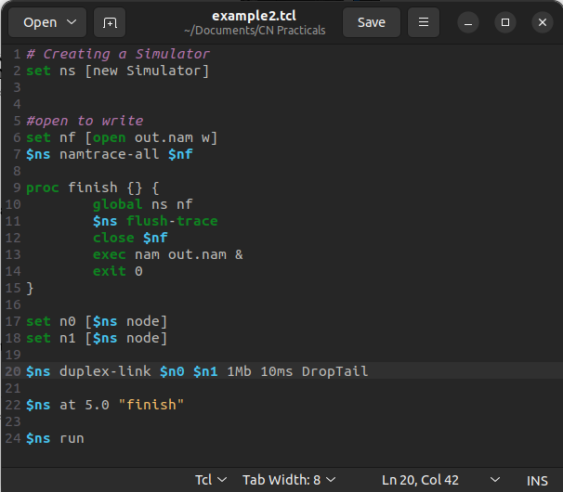
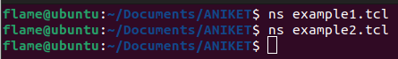

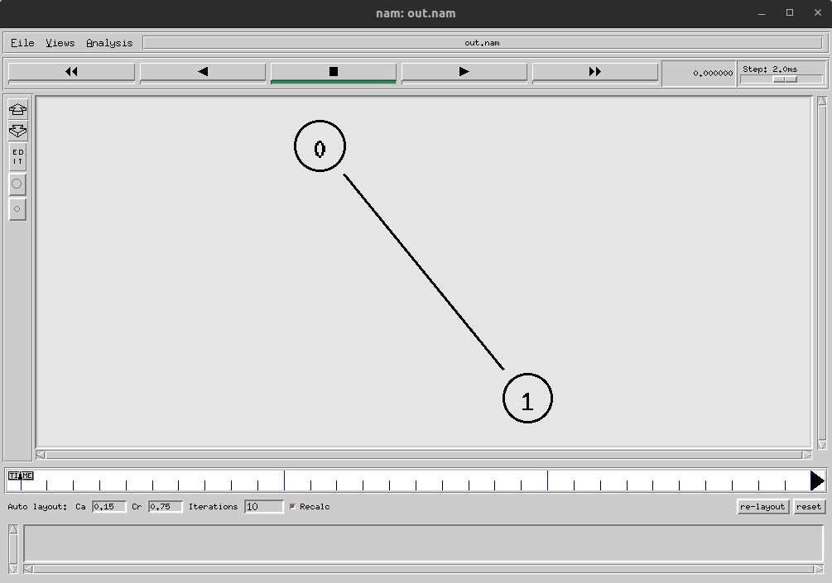
3. Sending data
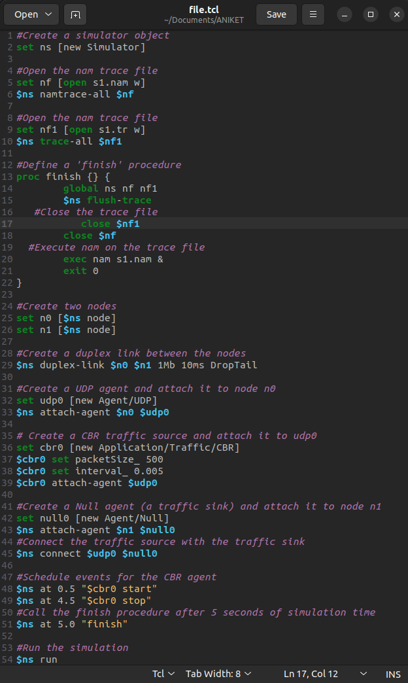
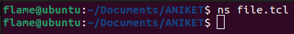
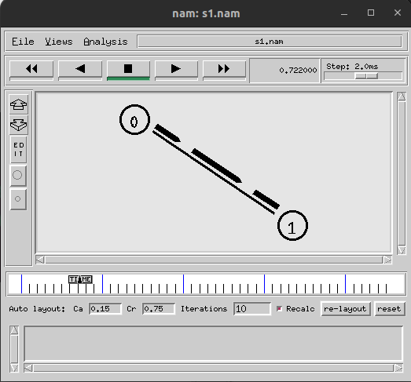

Conclusion : Thus we have written our script for two nodes network.

Experiment No. 5

Aim : To implement TCL scripts for topology with Graphical simulation of traffic consideration for TCP
using NAM

Laboratory Outcome No : ITL401.3 (Demonstrate and measure different network scenarios and their performance behaviour.)

Theory :
TCL is a file extension for a script written in TCL. TCL (also pronounced tickle) stands for Tool Command Language. TCL files are text files containing TCL scripts. TCL is a dynamic open source language used for building web and desktop applications. Whether on Windows, Mac OS X, or Linux operating systems, TCL files can be opened and edited by WISH and TCLSH.

Code for sending data traffic
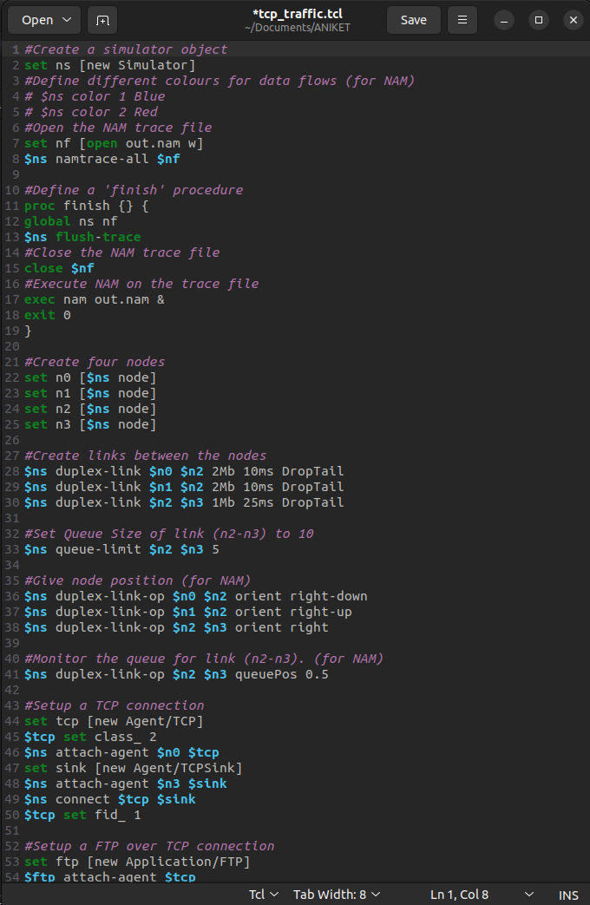

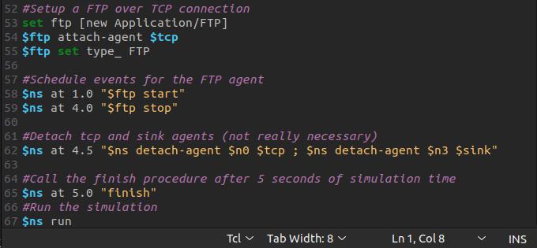
Executing the created code saved in the file
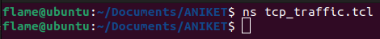
Output graphical simulation using NAM the traffic is flowing between node 0 as source and 3 as destination
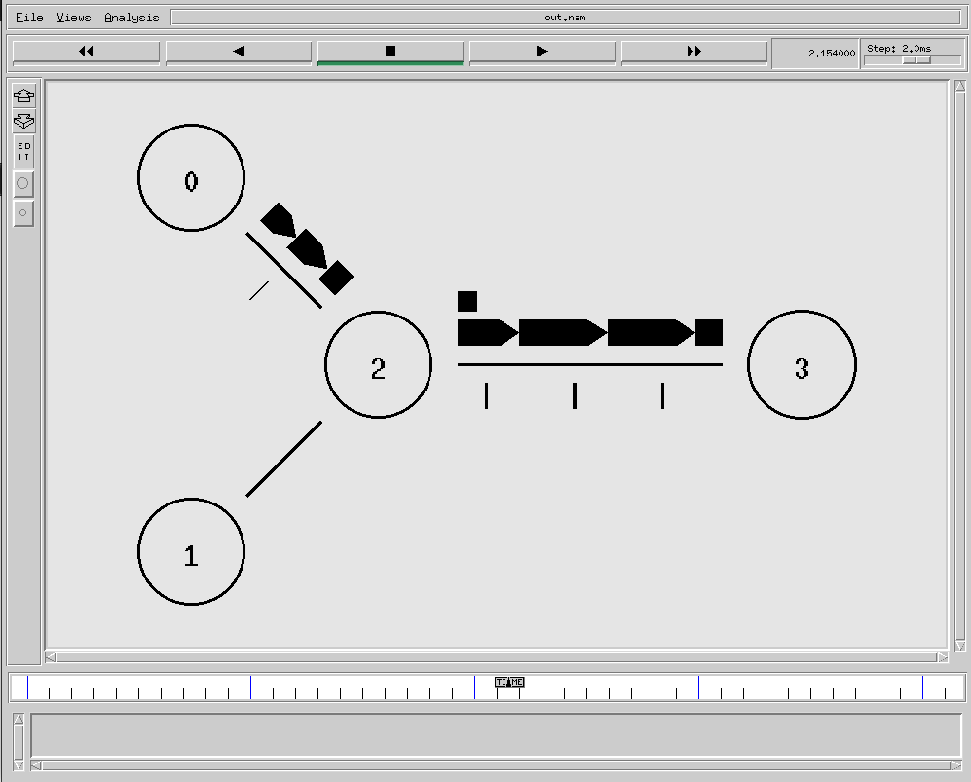

Conclusion : Thus we have configured the network passing FTP traffic over TCP.

Experiment No. 6

Aim : To simulate and study the Distance Vector routing algorithm using simulation.

Laboratory Outcome No : ITL401.3 (Demonstrate and measure different network scenarios and their performance behaviour.)

Theory :
Distance Vector Routing is one of the routing algorithm in a Wide Area Network for computing shortest path between source and destination. The Router is one main devices used in a wide area network. The main task of the router is Routing. It forms the routing table and delivers the packets depending upon the routes in the table-either directly or via an intermediate devices. Each router initially has information about its all neighbors. Then this information will be shared among nodes.

Program :

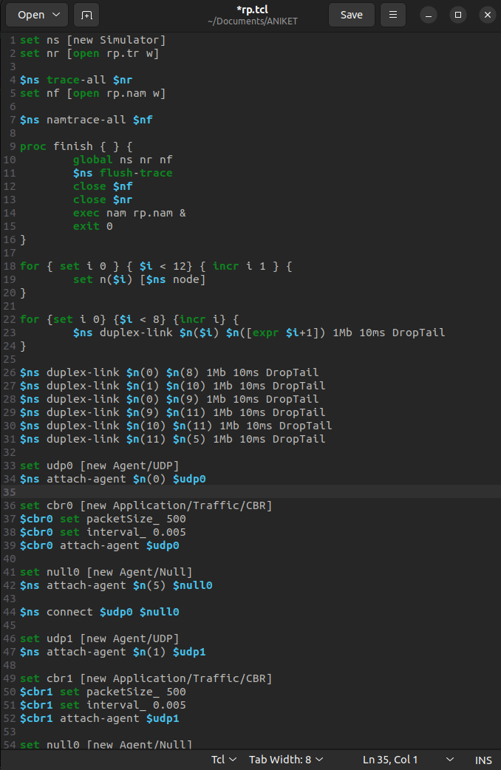

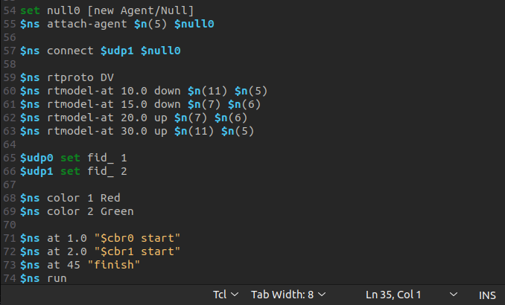

Running the code saved in the rp.tcl file
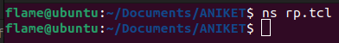

Output
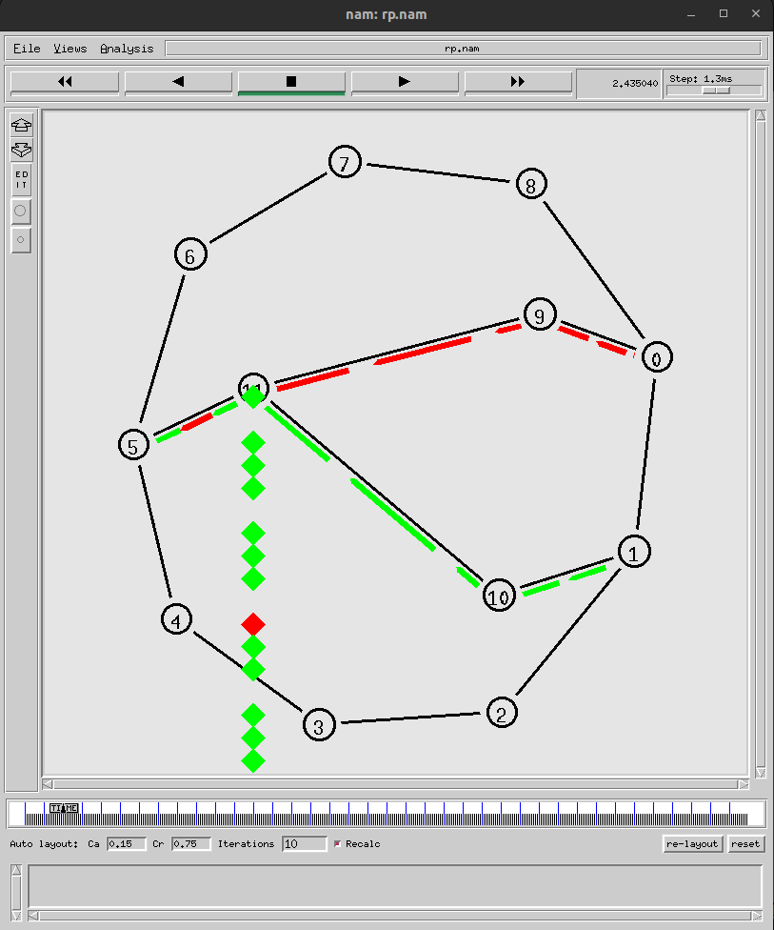

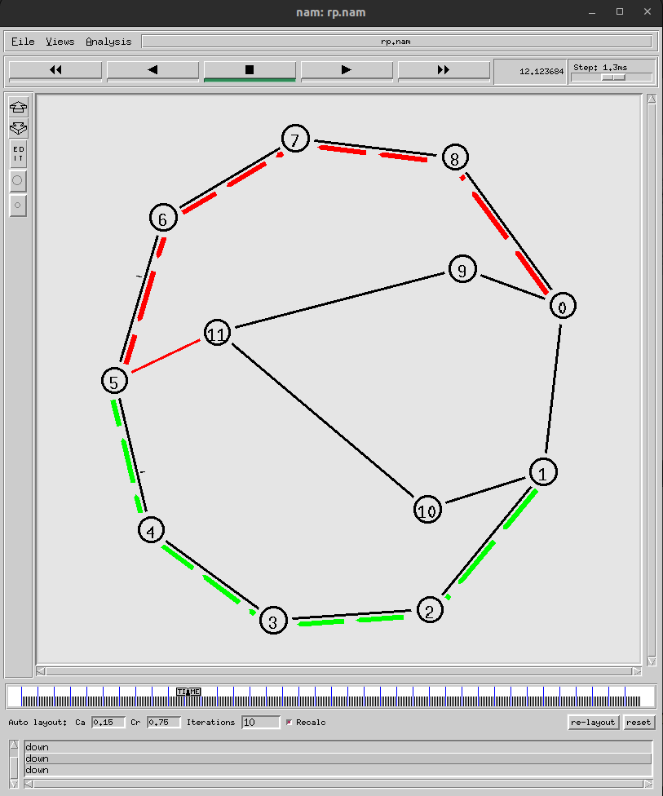

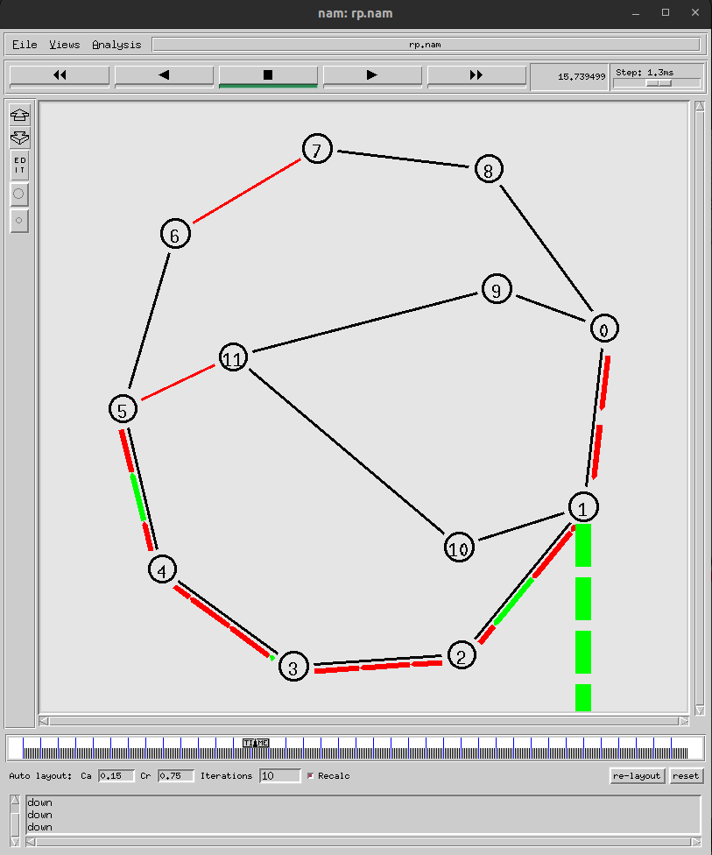
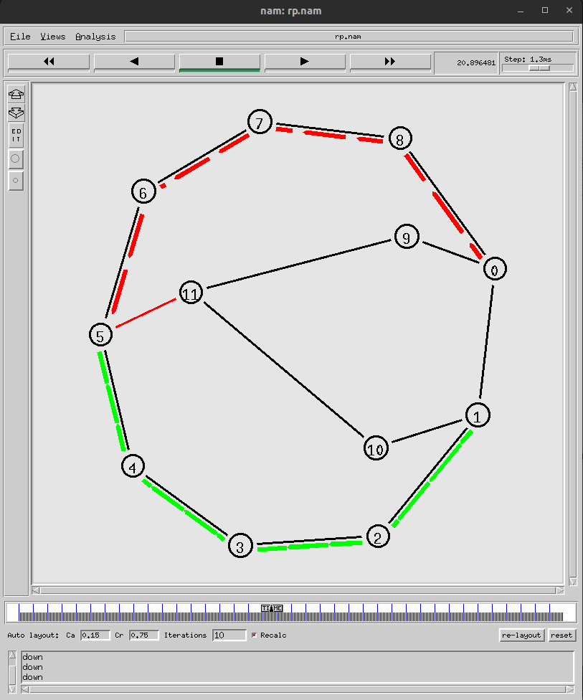
Conclusion : Thus we have implemented and simulated DV and LS in NS2.

Experiment No. 7

AIM : Understanding client-server socket and writing a small program for chat application

Theory :
In client-server applications, the server provides some service, such as processing database queries or sending out current stock prices. The client uses the service provided by the server, either displaying database query results to the user or making stock purchase recommendations to an investor.

The communication that occurs between the client and the server must be reliable. That is, no data can be dropped and it must arrive on the client side in the same order in which the server sent it.
TCP provides a reliable, point-to-point communication channel that client-server applications on the Internet use to communicate with each other. To communicate over TCP, a client program and a server program establish a connection to one another. Each program binds a socket to its end of the connection. To communicate, the client and the server each reads from and writes to the socket bound to the connection.

What Is a Socket?

Normally, a server runs on a specific computer and has a socket that is bound to a specific port number. The server just waits, listening to the socket for a client to make a connection request.
On the client-side: The client knows the hostname of the machine on which the server is running and the port number on which the server is listening. To make a connection request, the client tries to connect with the server on the server's machine and port. The client also needs to identify itself to the server so it binds to a local port number that it will use during this connection. This is usually assigned by the system.
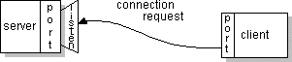
If everything goes well, the server accepts the connection. Once accepted, the server gets a new socket bound to the same local port and also has its remote endpoint set to the address and port of the client. It needs a new socket so that it can continue to listen to the original socket for connection requests while tending to the needs of the connected client.
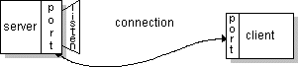
On the client side, if the connection is accepted, a socket is successfully created and the client can use the socket to communicate with the server.
The client and server can now communicate by writing to or reading from their sockets.
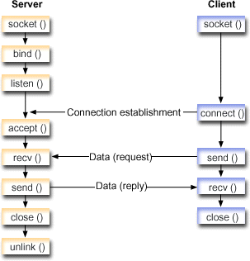

Definition :
A socket is one endpoint of a two-way communication link between two programs running on the network. A socket is bound to a port number so that the TCP layer can identify the application that data is destined to be sent.
Every TCP connection can be uniquely identified by its two endpoints.

The java.net package in the Java platform provides a class, java.net.Socket, that implements one side of a two‐way connection between your Java program and another program on the network.

java.net includes the ServerSocket class, which implements a socket that servers can use to listen for and accept connections to clients.
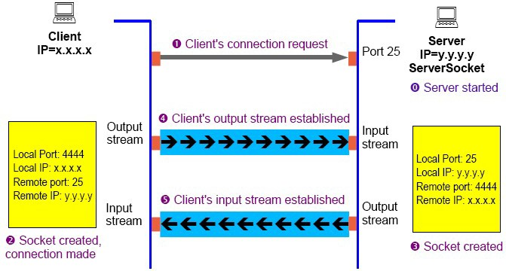
CODE :
CLIENT SIDE:
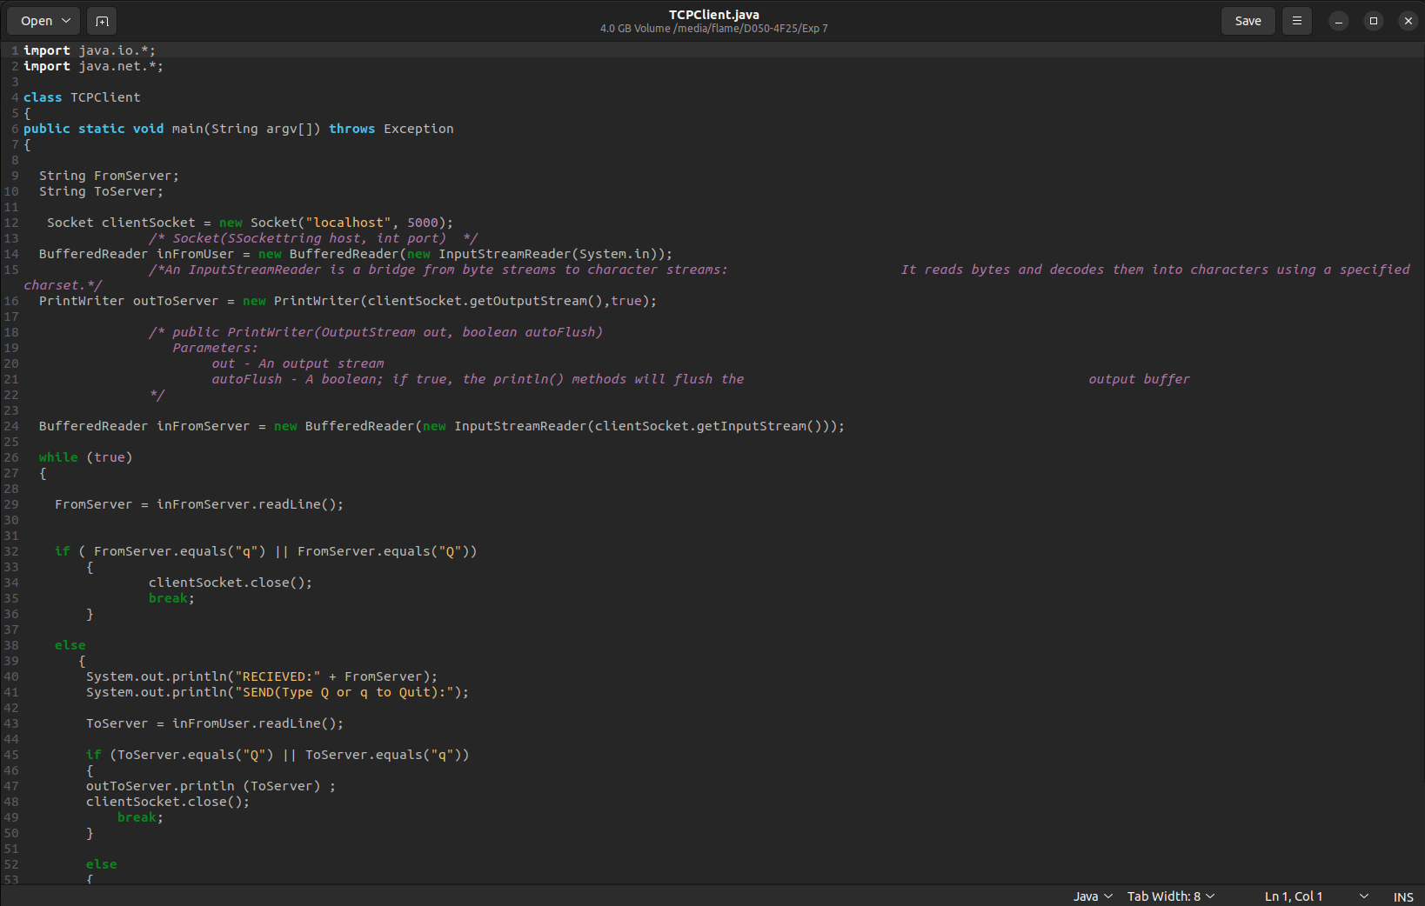
SERVER SIDE:
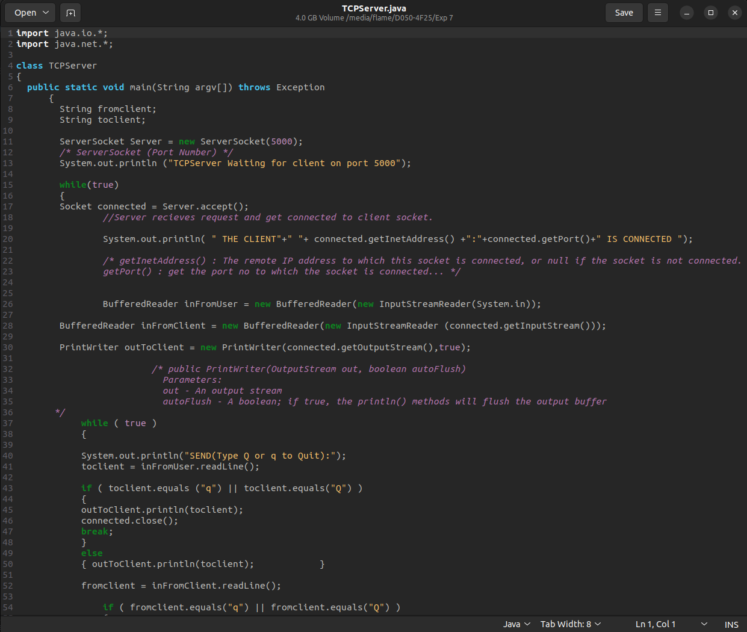
Conclusion :
CLIENT SIDE:
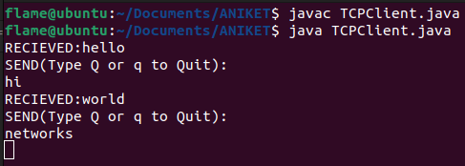
SERVER SIDE:
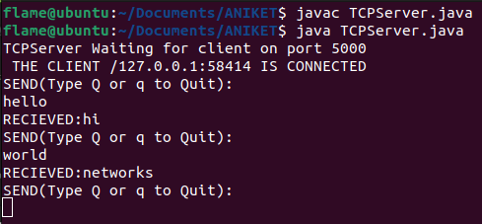
References :
1) https://www.tutorialspoint.com/unix_sockets/what_is_socket.htm
2) https://www.geeksforgeeks.org/socket-programming-in-java/
3) http://moodle.dbit.in/mod/folder/view.php?id=29945

Experiment No. 8
Aim : To develop a chat application using Socket Programming (UDP) .

Pre-requisite :
Knowledge of Socket programming.

Learning Objectives :
1. Students will be able to develop application which requires network service.

Laboratory Outcome No : ITL401.5 Implement the socket programming for client server architecture.

Theory :

What ls a Datagram?
A datagram is an independent, self-contained message sent over the network whose arrival, arrival time, and content are not guaranteed.

Writing a Datagram Client and Server?
The java.net package contains three classes to help you write Java programs that use datagrams to send and receive packets over the network :
DatagramSocket, DatagramPacket, and MulticastSocket. An application can send and receive DatagramPackets through a DatagramSocket. In addition, DatagramPackets can be broadcast to multiple recipients all listening to a MulticastSocket.

Sending and receiving data
Packets to be sent or received are represented by instances of the java.net.DatagramPacket class.To send a packet you must instantiate a DatagramPacket, set its port and lP address to the port and lP address of the host to where you want to send the packet and set its data buffer with the data you want to send.

The data buffer is specified as an array of bytes, but you can use just part of an array specifying the offset and the length of the piece you want to use.
The class Datagram Packet provides several constructors and methods to set the address, port, and data buffer.
Once you have constructed and filled a DatagramPacket, you can send it using the method DatagramSocket.send (DatagramPacket). Notice that since UDP is connectionless, the method success does not mean the packet has been delivered to the destination, only that it has been sent by the TCP/IP stack. Delivery confirmation, if needed, must be implemented at a higher level within your application.
In order to receive a packet, you must construct a DatagramPacket, set a data buffer large enough to hold the data you expect to receive, and call the method DatagramSocket.receive ( Datagram Packet).
One disadvantage of UDP is that you must specific the destination host's address and port on every packet to be sent. Another is that UDP sockets accept packets from any host. That is a consequence of the connectionless nature of UDP.
However, the Datagramsocket class provides the concept of a connection to a remote host that greatly simplifies implementations based on UDP. That feature is implemented by the method DatagramSocket.connect() , which connects the socket to a remote host.

While the socket is connected, the send method will only send packets to the connected host. That means you can leave the address and port of DatagramPackets you are going to send unset. ln fact, if you set them to anything other than the connected host's address and port, you will get an exception. Likewise, the receive method will accept packets only from the connected host's address and port.

Code :
CLIENT SIDE:
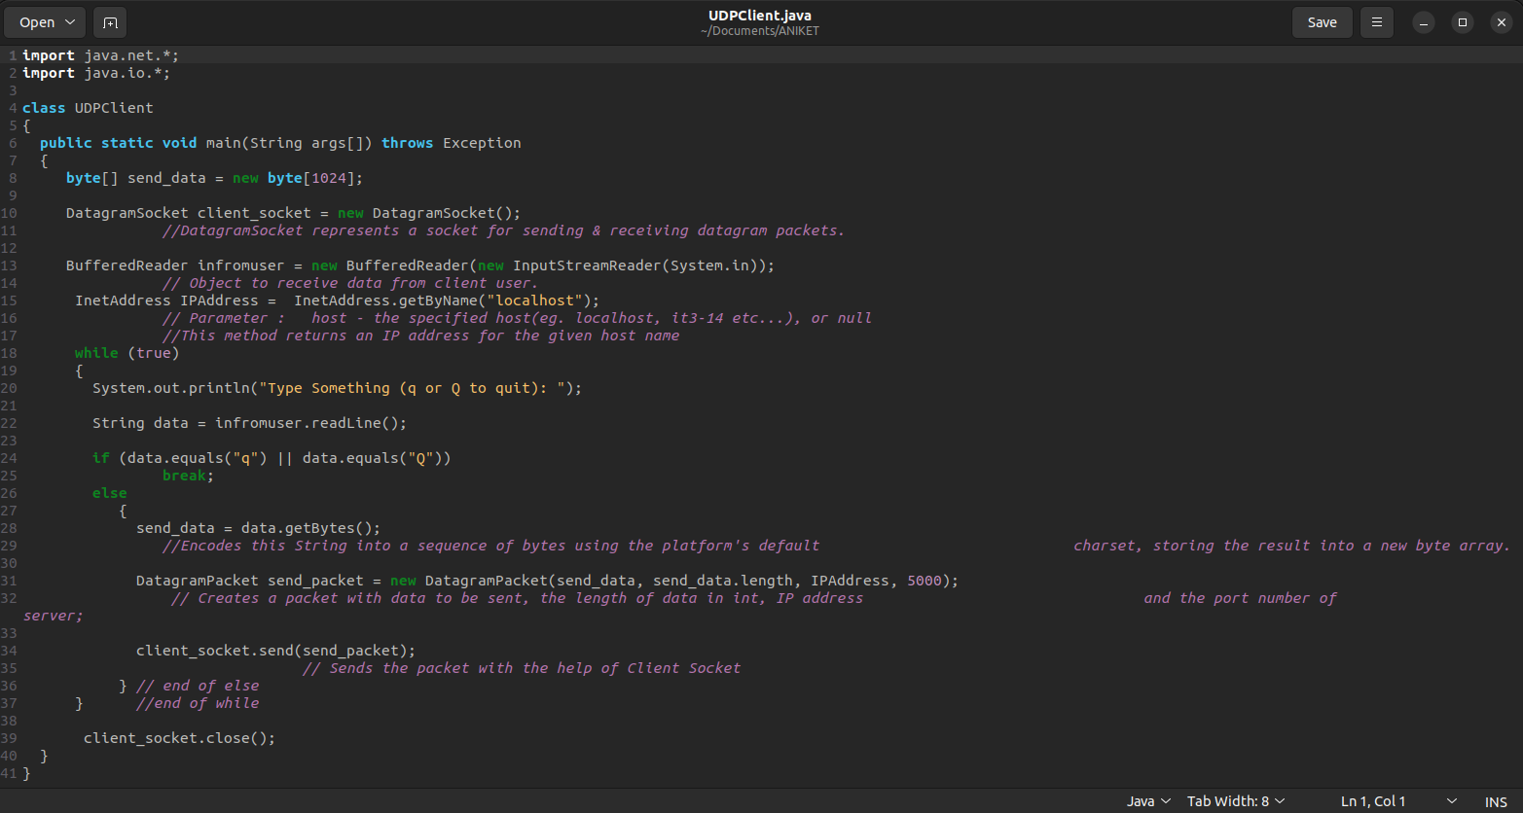

SERVER SIDE:
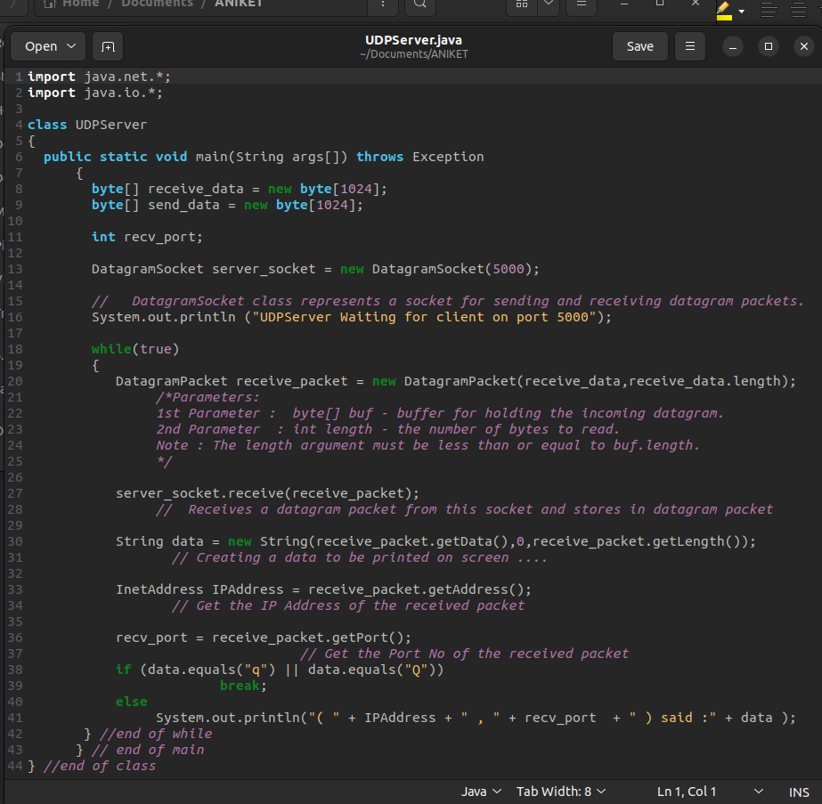
Conclusion :

CLIENT SIDE:
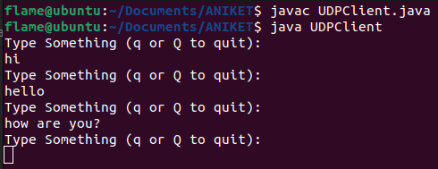

SERVER SIDE:
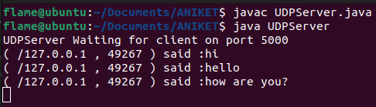

References :
- https://www.tutorialspoint.com/unix_sockets/what_is_socket.htm
- https://www.geeksforgeeks.org/socket-programming-in-java/
- http://moodle.dbit.in/mod/folder/view.php?id=29945

Experiment No. 9

Aim : To form a network and simulate routing protocol such as RIP

Theory :
Download Cisco Packet Tracer and follow the Steps discussed below:
1) Create three network as shown below. Use Drag and drop functionality for creating the network. You have a collection of devices at the left bottom of packet tracer tool. Just click on the device which you want in your network and then click on the logical pane.
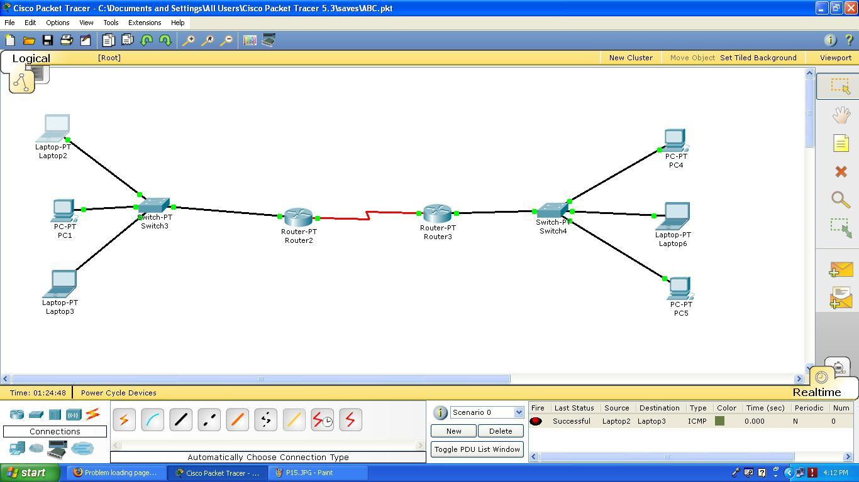
2) Here I have used 2 PC and 1 Laptop, Generic type of Switch and Generic type of Router. I have to assign IP address to each machine and interface of the router.
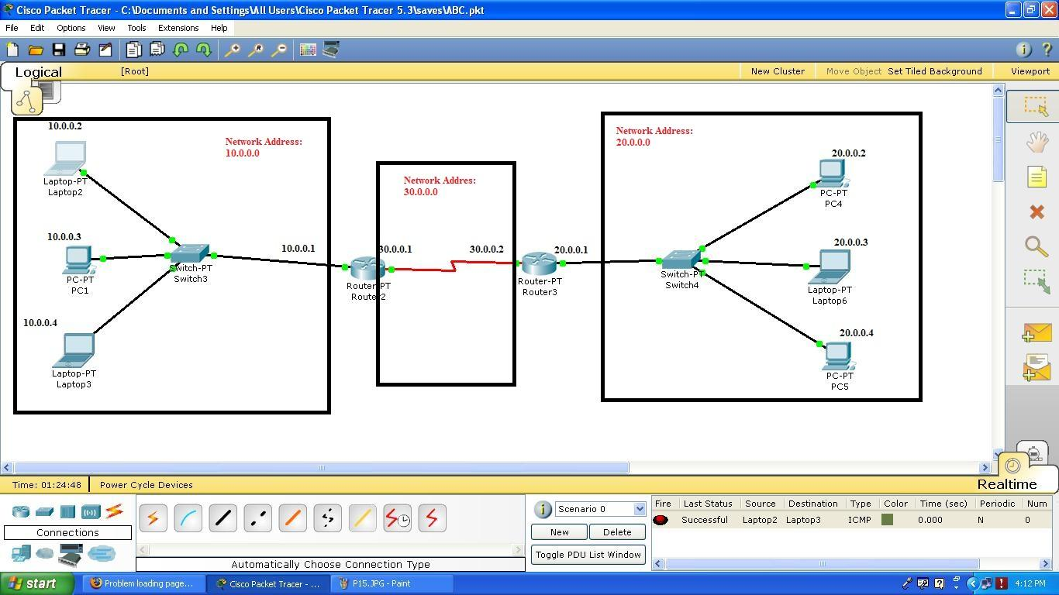
3) Let us know how to assign IP address and Subnet Mask to each machine. So double click on Laptop/PC , go to Config tag and click on FastEthernet button , you will see following window. Assign IP Address and Subnet Mask.

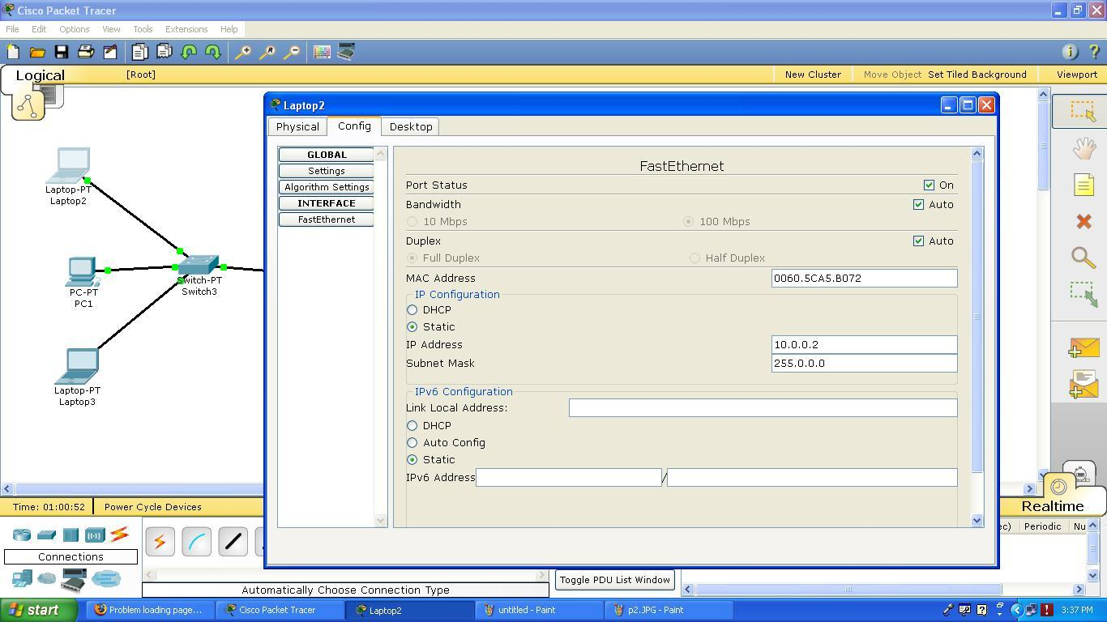
4) Now click on Settings button and add default Gateway as IP address of interface of router. Close the window. This is how you have configure the PC/Laptop.

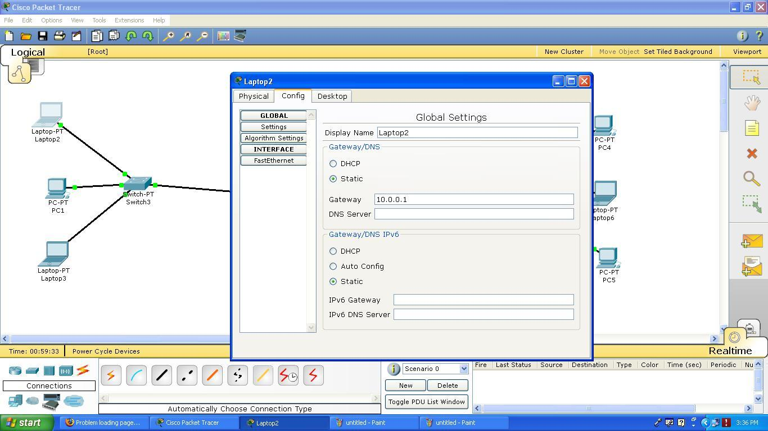
5) Now let us configure Router . So double click on router, click on config tab and then click on FastEthernet interface (Interface connected to switch). Set IP address and the subnet mask and make Port status “ON”
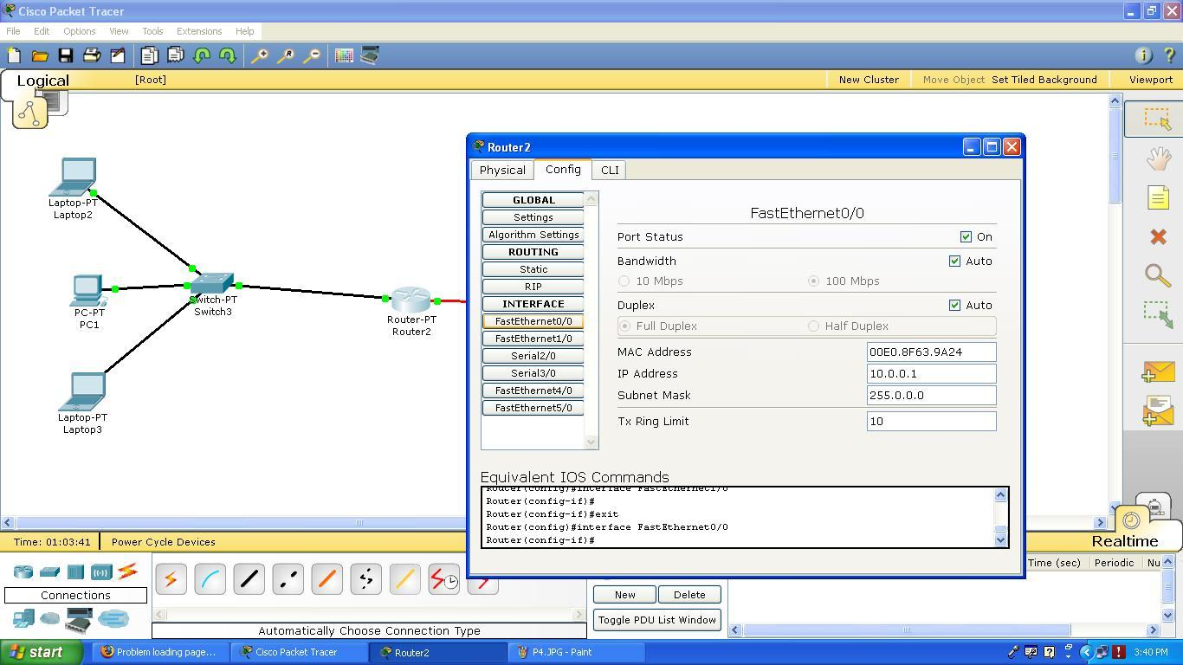
6) Click on Serial interface (Interface connected to other router). Set IP address and the subnet mask and make Port status “ON” . Also set the clock rate
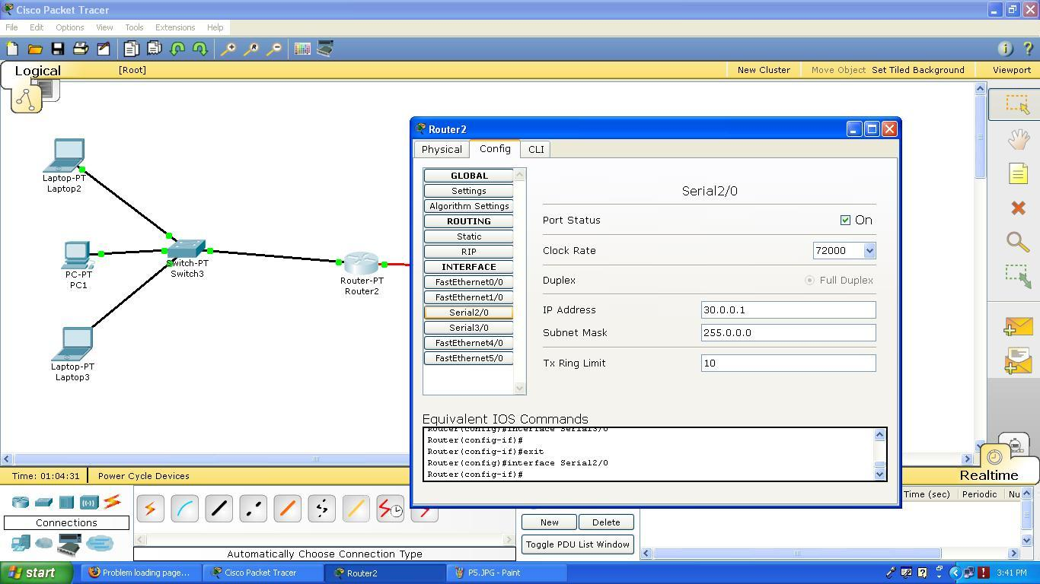
7) To transfer packet from one network to another, router should gather information about the network it is directly connected and should share these information with other router. In other words it should implement some routing algorithms such as Routing Information Protocol (RIP), Open Shortest Path First (OSPF) etc…. In these case we have implemented RIP routing algorithm and added network addresses of all the network
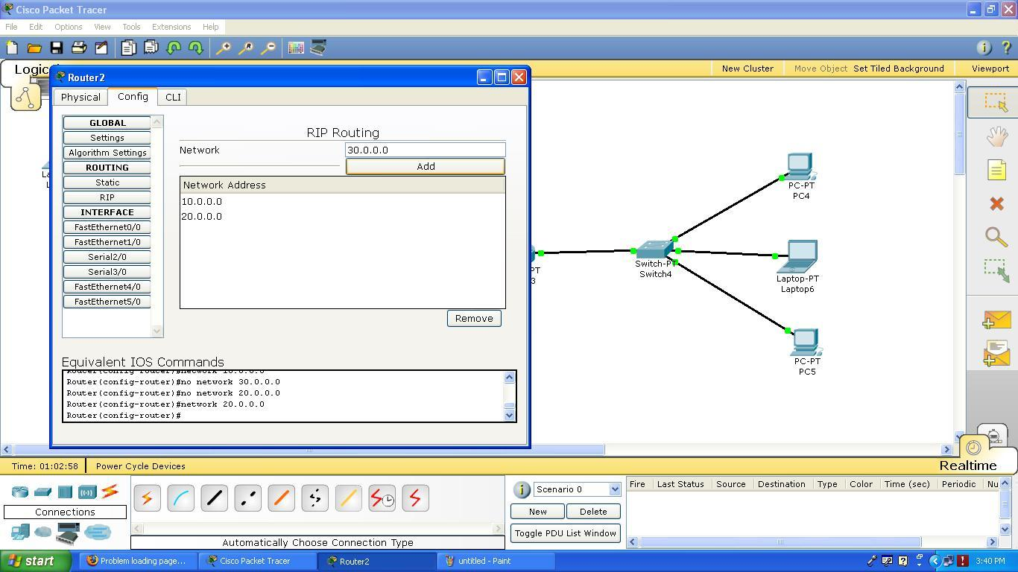

8) Configure another router in a same way.
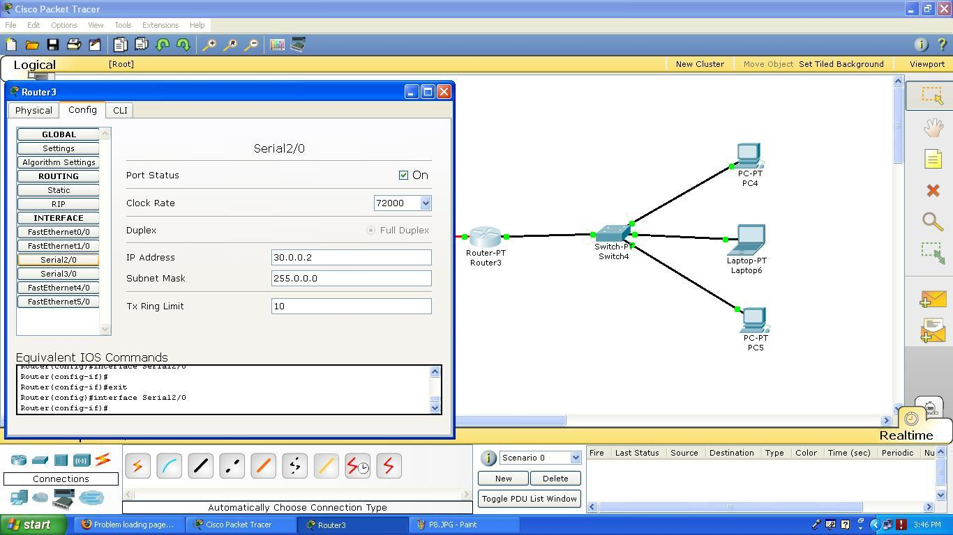
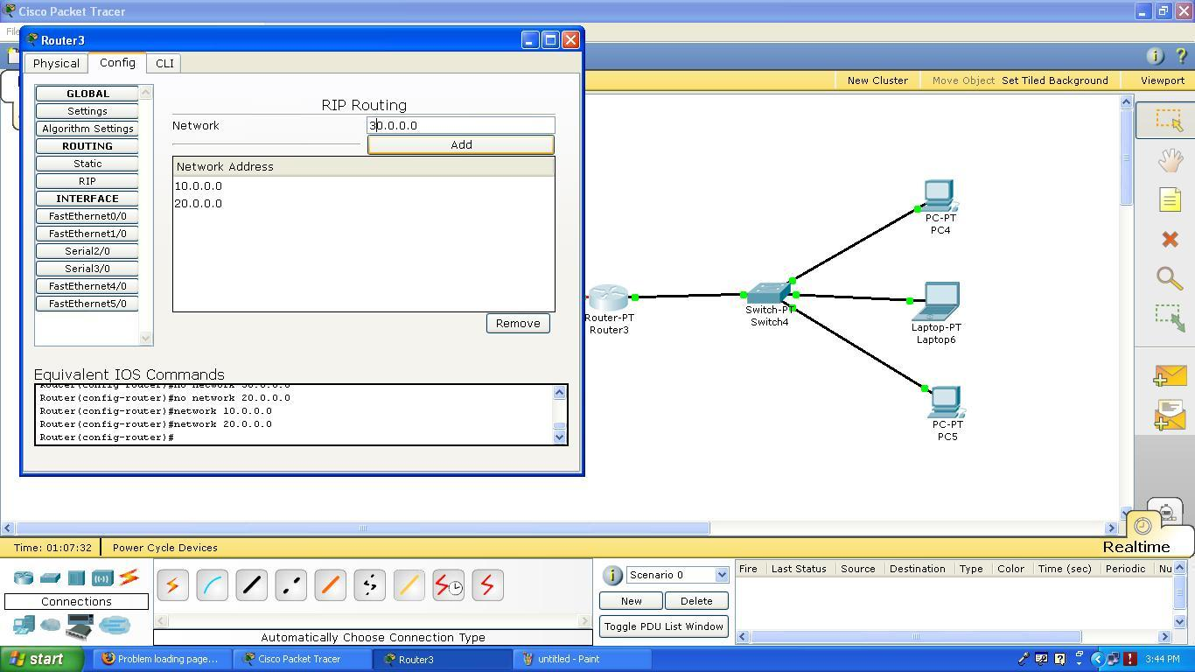
9) Once all the device are configure….click on the packet icon at right side panel and then click on sender and receiver machine. Start simulation mode and click on capture/Forward button to see step by step procedure to forward packet from source to destination.

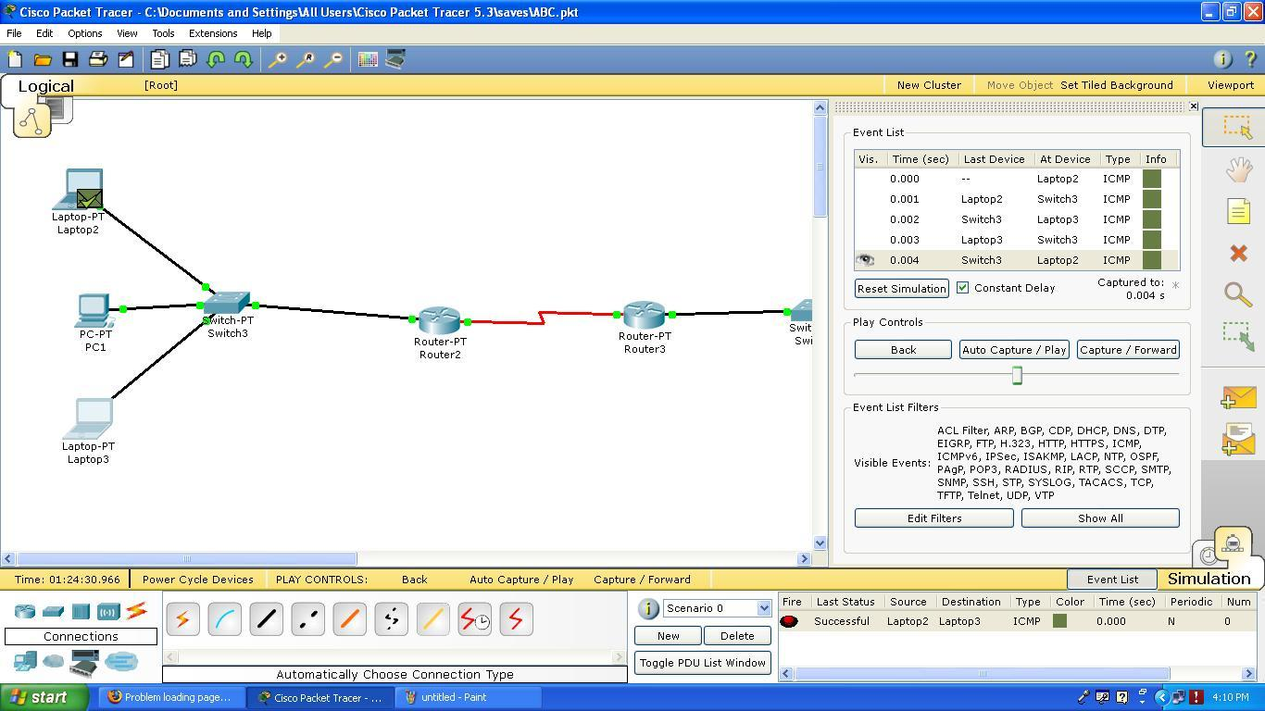

Experiment No. 10

Step 1:
1. Drag and drop six end devices.
2. Drag and drop the Router-PT(Generic ) and switch-pt(Generic ) through fast ethernet
3.Connect End devices to the switch using the Copper Straight wire through fast ethernet
4.Connect Switch to Router using Copper Straight Wire through fast Ethernet
5. Connect Router to Router using Serial DCE Wire through Serial .
Step 2:
End Devices-> Select the Generic Server-PT-> drag and drop the server which will act as a DHCP SERVER.
Step 3:
Connections -> select Copper Straight Connection->connect switch to DHCP SERVER through fast Ethernet.
Step 4:
SELECT ROUTER:
SELECT CONFIG----->appropriate FastEthernet Interface--------> and follow below steps:

SELECT CONFIG----->appropriate Serial Interface--------> and follow below steps:
Select Setting--->assign Gateway address and DNS server IP ADDRESS.
Select DHCP tab --->Enter following information.
Again SELECT ROUTER---->CONFIG---->RIP---->ADD NETWORK ADDRESS.
ON EACH INTERFACE OF ROUTER, GO AND EXECUTE BELOW CMD IN CLI: FOR THIS--->double click on interface---->then select CLI TAB. ip helper-address DO ABOVE STEP FOR EACH ROUTER.
Now let us test whether DHCP is working or not
SELECT END DEVICE GO TO DESKTOP TAB----->SELECT IP CONFIGURATION--------->SELECT DHCP
Let us configure DNS SERVER: GO TO CONFIG TAB------->SELECT FASTETHRNET
SELECT SETTING-----> ASSIGN DEFAULT GATEWAY AND DNS SERVER.

Step 5:
MAKE DHCP SERVER OFF.
Step 6:
THEN SELECT DNS OPTION FROM CONFIG TAB.
NAME: www.ctnc.com
TYPE : A Record
ADDRESS: 30.0.0.2 (i.e.Address of Web server in your network...so add one more server in network and
configure in the same way like your DNS server ... )
Then add this information.
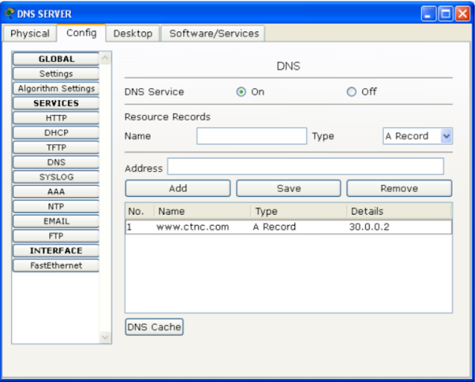

Step 7:
THEN SELECT WEB SERVER.
GO TO CONFIG TAB----->SELECT FASTEHRNET------>SET IP ADDRESS AND SUBNET MASK.
Step 8:
THEN SELECT SETTING OPTION AND SET GATEWAY AND DNS SERVER.
SELECT ANY END DEVICE FROM NETWORK.
GOTO TO DESKTOP TAB------>SELECT WEB BROWSER------->AND SPECIFY THE URL(i.e. given
above(www.ctnc.com))------->CLICK ON GO BUTTON.

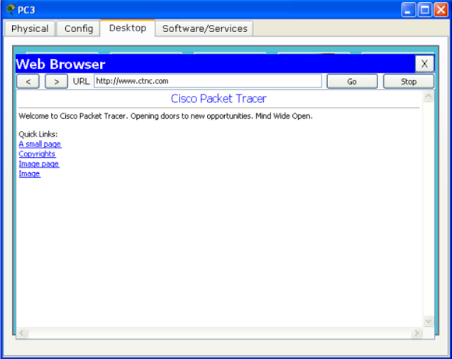

Conclusion : We have successfully creating a simple network and configured DHCP, DNS and HTTP server.

